 CHEMICAL ENGINEERING TRANSACTIONS  VOL. xxx, 2026 | A publication of  
The Italian Association
of Chemical Engineering
Online at www.cetjournal.it

Guest Editors: Flavio Manenti, Botir Usmonov, Alessandro Di Pretoroz

Copyright © 2026, AIDIC Servizi S.r.l.
ISBN 979-12-81206-xx-x; ISSN 2283-9216

“Determination of Moisture, Fat, Protein, Fibre, and Ash Content in Flours Obtained from Various Grains Grown Under the Conditions of Uzbekistan Using the Near-Infrared Spectroscopy (NIRS) Method.”

Orifova Muyassar Shukrullojon qizi ^{a,}*, Azizov Olimjon Toxirovich ^{b}, Jumaev Botir Melibayevich ^{c}
ª Tashkent Institute of Chemical Technology PhD doctoral student. muassarorifova@gmail.com*
^{b} Candidate of Chemical Sciences, Associate Professor Tashkent Institute of Chemical Technology.
^{c} PhD Associate Professor Yangiyer Branch of the Tashkent institute of chemical Technology.

In the food industry today, evaluating the quality of various grains and their derived flours is of great importance. Determining the content of moisture, fat, protein, fiber, and ash in flour is essential. The NIRS method is a rapid, accurate, and semi-quantitative analytical technique. Unlike conventional methods, this approach does not require special reagents or time-consuming sample preparation, and the initial results are considered reliable. Using this method, it is possible to simultaneously determine the moisture, fat, protein, fiber, and ash content of flour.
The study objects were flour samples obtained from wheat (“O‘zbekiston-25”), rice (“Alanga”), corn (“O‘zbekiston-18”), oats (“Qirqma”), and buckwheat (“Mayskiy”) varieties cultivated under the conditions of Uzbekistan. To obtain accurate results, these grains were first milled to a particle size of 0.3–0.5 mm. The tests were conducted using a “NIR ProxiMate” analyzer manufactured by BUCHI Labortech, Switzerland. To evaluate the reliability and repeatability of the obtained results, each sample was analyzed in triplicate. The moisture, fat, protein, fibre, and ash contents determined by the Near-Infrared Spectroscopy (NIRS) method showed a high degree of agreement with the results obtained using conventional analytical methods. The consistency of the replicate analyses confirmed that the NIRS method is a rapid, accurate, and reliable technique for determining the physicochemical properties of cereal flours.

1.Introduction

Cereals are considered the primary source of energy and essential nutrients in human nutrition. In developing countries, including Uzbekistan, cereal crops such as wheat, rice, corn, oats, and buckwheat constitute an important part of the daily diet. The chemical composition of flours obtained from these grains particularly the content of moisture, protein, fiber, ash, and fat is a key indicator that determines their nutritional value, technological properties, and storage stability.
Although conventional chemical analysis methods (Kjeldahl, Soxhlet, gravimetric, and others) provide high accuracy, they require considerable time and chemical reagents. Therefore, there is an increasing demand in the modern food industry for rapid and environmentally friendly analytical techniques. One such method is Near-Infrared Spectroscopy (NIRS), which enables the simultaneous determination of multiple parameters without destroying the sample (Cozzolino, D., 2021).
The agro-climatic conditions of Uzbekistan have a significant impact on the chemical composition of grains. As a result of soil and climate characteristics, irrigation regimes, and agronomic practices, the composition of cultivated grains may vary across different regions. Therefore, comprehensive analysis of flours obtained from local raw materials using NIR spectroscopy is of considerable scientific and practical importance. The quality and safety of wheat flour are of great public concern, as they are directly related to flour product quality and human health. Hence, effective and convenient analytical methods are required for quality and safety control of wheat flour. Near-Infrared (NIR) spectroscopy has become an ideal technique for evaluating the quality and safety of wheat flour due to its rapid, efficient, non-destructive nature and its ability to provide measurements without contaminating the environment (S. Zhang et al., 2022).
Wheat (Triticum aestivum L.) is one of the three most important cereal crops in the world and is widely cultivated. It plays a significant role in human nutrition and is a key ingredient in many food products. Among cereal grains, wheat is of major agricultural importance. It serves as a primary food source for 36% of the global population and is cultivated on approximately 70% of the world’s agricultural land. Globally, wheat provides about 55% of the carbohydrates consumed and 2% of total dietary calories. In terms of production volume and cultivated area, it surpasses all other cereal crops (including rice, corn, and others), is grown under a wide range of climatic conditions, and is therefore considered one of the most important cereal crops in the world (Khalid et al., 2023; da Silva et al., 2023).

2. Materials and methods

The aim of this study is to determine the moisture, fat, protein, fiber, and ash content of flours obtained from various grains cultivated under the conditions of Uzbekistan using the near-infrared spectroscopy (NIRS) method, and to evaluate the accuracy and applicability of this technique. This method has several advantages, including the ability to measure solid and semi-solid samples in less than 10 seconds, providing repeatable results for heterogeneous samples through automatic multi-point measurement, and easy integration with automated systems or other analytical techniques (e.g., titration) (Metrohm, 2023).
Materials: As samples, grains of wheat variety “O‘zbekiston-25”, rice variety “Alanga”, corn variety “O‘zbekiston-18”, oats variety “Qirqma”, and buckwheat variety “Mayskiy”, cultivated under the conditions of Uzbekistan, were used.
Equipment and reagents: Equipment required for the NIRS method: “NIR ProxiMate” analyzer manufactured by BUCHI Labortech (Switzerland), computer and software system, laboratory mill and sieve set, Petri dishes, analytical balance.
Methods: Near-Infrared Spectroscopy (NIRS) method: The analyses were performed using a “NIR ProxiMate” analyzer manufactured by BUCHI Labortech (Switzerland). The instrument was switched on and allowed to stabilize for 30 minutes before measurements.
Calibration models were developed using BUCHI NIR Solutions software based on the Partial Least Squares (PLS) regression method, which is widely used for quantitative analysis of food matrices. The laboratory temperature was maintained at 20–25°C.
Representative samples of wheat (“O‘zbekiston-25”), rice (“Alanga”), corn (“O‘zbekiston-18”), oats (“Qirqma”), and buckwheat (“Mayskiy”) cultivated under the conditions of Uzbekistan were collected. The grains were first cleaned and ground using a laboratory mill. To ensure high analytical accuracy, the flour was sieved through a 0.3–0.5 mm sieve set.
Each sample (50 g) was weighed using an analytical balance and placed into Petri dishes, and the surface was leveled and covered. The samples were then placed at the spectral center of the instrument, and sample information was entered into the analyzer interface before starting the measurement.
Spectral measurements were performed in the wavelength range of 780–2500 nm. Each sample was measured three times, and the results were expressed as mean values. The obtained spectral data were processed mathematically using the instrument’s software. The coefficient of determination (R²) was used to evaluate the reliability and accuracy of the NIR ProxiMate analyzer results. Each parameter — moisture, fat, protein, fiber, and ash — was analyzed in triplicate, and the R² values were calculated to confirm the correlation between repeated measurements. R² values close to 1.0 indicate high precision and reproducibility of the method under the given experimental conditions.
Moisture determination (Gravimetric method): The moisture content of the flour samples was determined according to AOAC 925.10 / ISO 712:2009 standards. The samples were dried in a drying oven at 105 ± 3°C for 1 hour. The moisture content was calculated as the difference between the masses measured before and after drying. The lost mass was considered as moisture content.
Fat determination (Soxhlet extraction method): The fat content was determined according to AOAC 920.39 / ISO 11085:2015 standards. The dried sample was extracted using an organic solvent (n-hexane or diethyl ether) in a Soxhlet apparatus under continuous reflux conditions. After evaporation of the solvent, the remaining lipid residue (crude fat) was weighed, and the fat content was calculated based on the mass difference.
Protein determination (Kjeldahl method): The protein content was determined according to AOAC 979.09 / ISO 20483:2013 standards. The Kjeldahl method consists of three main stages: mineralization—organic matter is decomposed by concentrated sulfuric acid, converting nitrogen into ammonium sulfate; distillation—the ammonium sulfate is treated with alkali (NaOH) to release ammonia (NH₃), which is then collected in a boric acid (H₃BO₃) solution; and titration—the collected ammonia is titrated with a standard acid solution.
Fiber content determination (Crude fiber method): The crude fiber content was determined according to AOAC 962.09 / ISO 6865:2000 international standards. Crude fiber is defined as the residue remaining after sequential treatment with 1.25% sulfuric acid (H₂SO₄) and 1.25% sodium hydroxide (NaOH) solutions, followed by drying and ashing. The fiber content was calculated as the mass loss after ignition of the dried residue. This residue mainly consists of cellulose and lignin compounds.
Ash content determination (muffle furnace method): The ash content of the samples was determined according to AOAC 923.03 / ISO 2171:2023 standards. The samples were incinerated in a muffle furnace at a high temperature of 550°C. Organic matter was completely decomposed, leaving only inorganic mineral residue (ash). The mineral residue was further ashed until a constant mass was achieved and then measured using the gravimetric method.

3. Results and discussion.
The moisture, protein, fat, ash, and fiber contents of flours obtained from various grains were determined using a Near-Infrared Spectroscopy (NIRS) analyzer, and the following results were obtained. Figures 1–5 present the quality parameters of flours obtained from different grains.

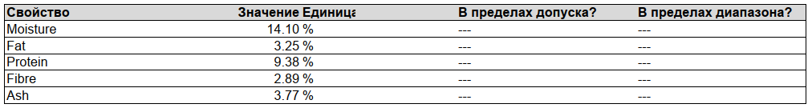
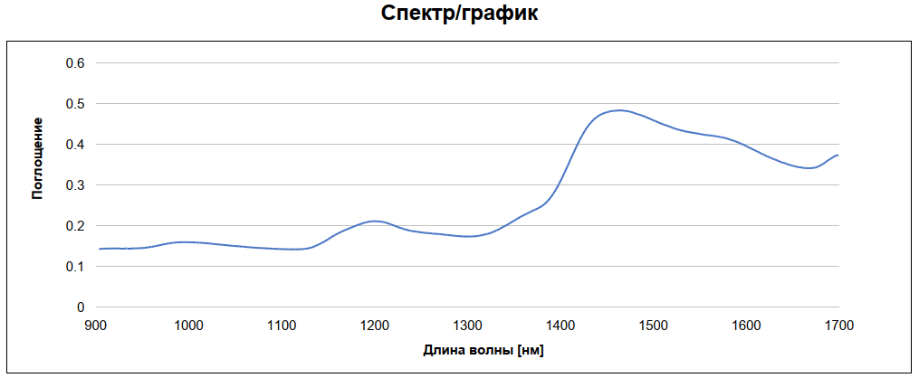
Figure 1. NIRS analyzer results for the moisture, fat, protein, fiber, and ash content of wheat flour.

The NIRS analysis predicted moisture, fat, protein, fibre, and ash contents of 14.10%, 3.25%, 9.38%, 2.89%, and 3.77%, respectively. The moisture content indicates that the wheat flour was within the typical range for commercial flour samples, while the protein content reflects medium protein quality suitable for general bakery applications. The measured fat, fibre, and ash contents are also consistent with the expected chemical composition of wheat flour.

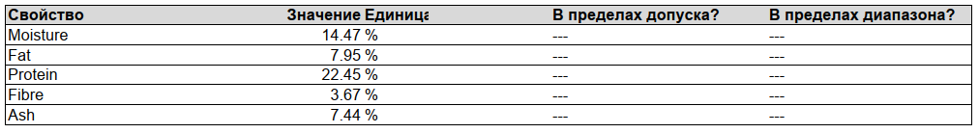
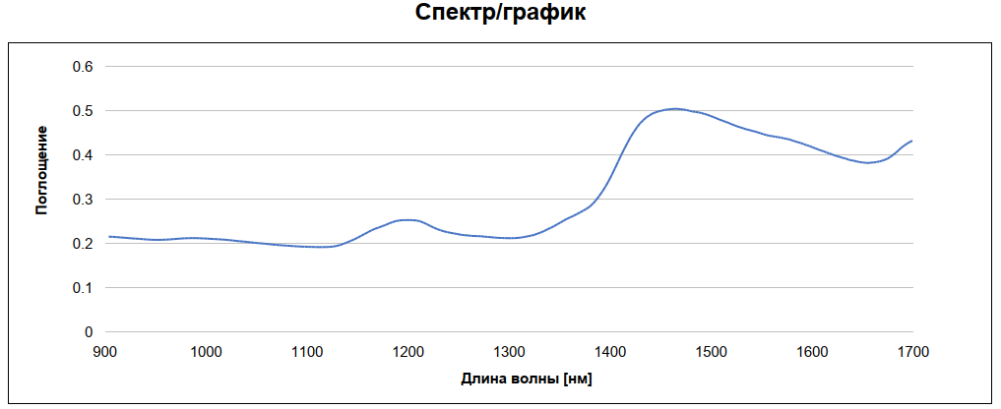
Figure 2. NIRS analyzer results for the moisture, fat, protein, fiber, and ash content of buckwheat flour.

Figure 2 shows the NIR spectrum and the physicochemical composition of buckwheat flour determined by Near-Infrared Spectroscopy (NIRS). The NIRS analysis revealed that buckwheat flour contained 14.47% moisture, 7.95% fat, 22.45% protein, 3.67% fibre, and 7.44% ash. As illustrated in the figure, buckwheat flour exhibited the highest protein, fat, fibre, and ash contents among the cereal flours analyzed, highlighting its superior nutritional composition.

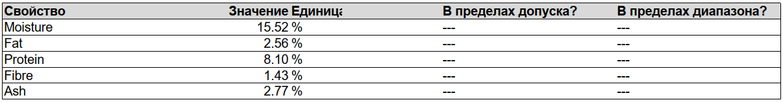
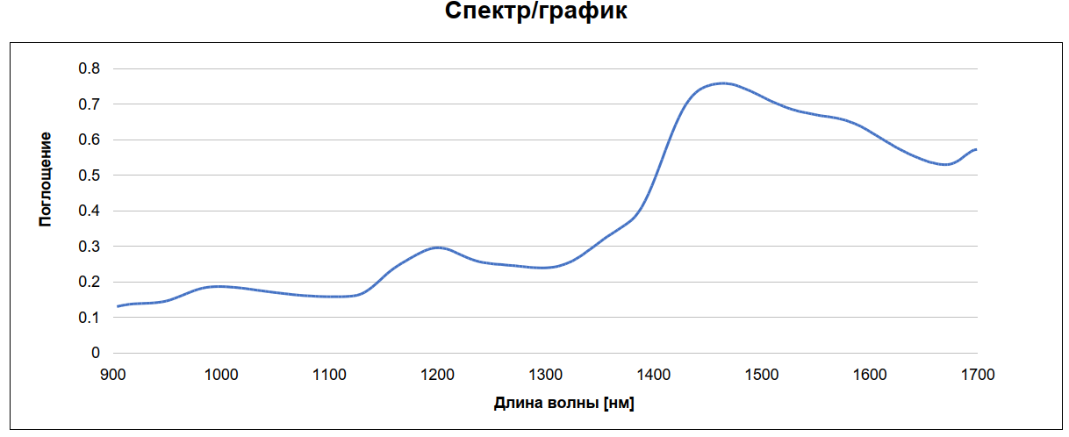
Figure 3. NIRS analyzer results for the moisture, fat, protein, fiber, and ash content of rice flour.

Figure 3 presents the NIR spectrum and the physicochemical composition of rice flour determined by Near-Infrared Spectroscopy (NIRS). The NIRS analysis revealed that the rice flour contained 15.52% moisture, 2.56% fat, 8.10% protein, 1.43% fibre, and 2.77% ash.

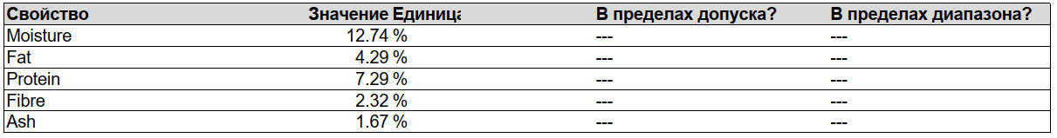
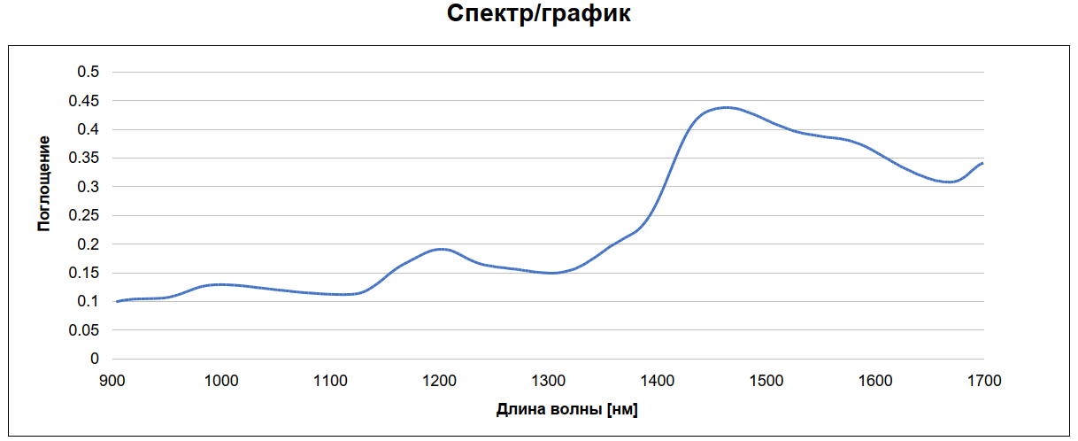
Figure 4. NIRS analyzer results for the moisture, fat, protein, fiber, and ash content of corn flour.

Figure 4 presents the NIR spectrum and the physicochemical properties of corn flour determined using the Near-Infrared Spectroscopy (NIRS) method. According to the analysis, the corn flour contained 12.74% moisture, 4.29% fat, 7.29% protein, 2.32% fibre, and 1.67% ash.

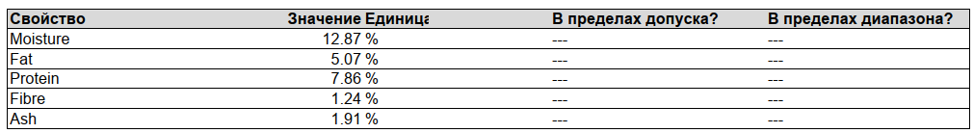
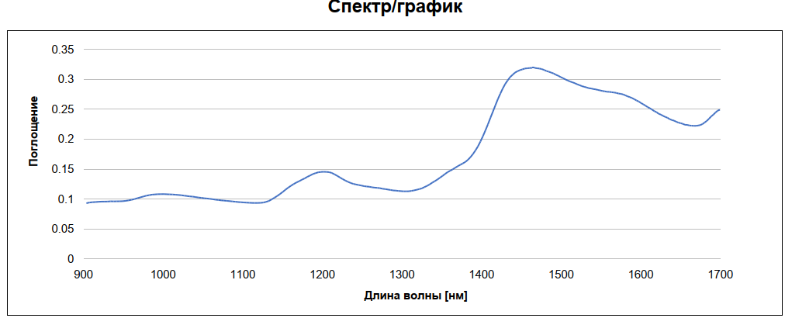
Figure 5. NIRS analyzer results for the moisture, fat, protein, fiber, and ash content of oat flour.

Figure 5 presents the NIR spectrum and the physicochemical properties of oat flour determined using the Near-Infrared Spectroscopy (NIRS) method. According to the analysis, the oat flour contained 12.87% moisture, 5.07% fat, 7.86% protein, 1.24% fibre, and 1.91% ash.

3.2 Experimental results obtained by classical methods based on international standards (Table 1)

Table 1. Moisture, fat, protein, fiber, and ash contents of flours obtained from various grains determined by classical methods.

Sample Moisture % Fat % Protein % Fibre % Ash%
Wheat flour 14,2 2.9 9 2.5 3
Buckwheat flour 14.2 7.2 21.8 3.2 7.1
Rice flour 15.2 2.2 8.0 1.5 2.5
Corn flour 13 4.2 7.1 2.2 1.6
Oat flour 12.5 4.8 7.2 1.2 1.8

The moisture, fat, protein, fibre, and ash contents of wheat, buckwheat, rice, corn, and oat flours are presented in Figure 1. The results demonstrated considerable variation in the chemical composition of the investigated flours, depending on the cereal type.
The moisture content ranged from 12.5% to 15.2%, with the highest value observed in rice flour (15.2%) and the lowest in oat flour (12.5%). Fat content varied between 2.2% and 7.2%; buckwheat flour exhibited the highest fat content, whereas rice flour showed the lowest value.
Buckwheat flour contained the highest protein content (21.8%), significantly exceeding that of the other flour samples. The protein contents of wheat, rice, corn, and oat flours were 9.0%, 8.0%, 7.1%, and 7.2%, respectively. The elevated protein content of buckwheat flour indicates its superior nutritional and biological value compared with the other investigated cereal flours.
The fibre content ranged from 1.2% to 3.2%, while the ash content varied between 1.6% and 7.1%. Buckwheat flour exhibited the highest values for both fibre and ash, indicating a greater concentration of dietary fibre and mineral constituents than the other cereal flours.

3.3 Comparative graph of results obtained by NIRS and classical methods (Figure 6).

Figure 6. Comparative graph of the moisture, fat, protein, fiber, and ash contents of flours obtained from various grains using NIRS and classical methods.

The obtained data show that the results from the NIRS method generally agree with those obtained from classical methods in terms of overall trend; however, small differences were observed for some components.
In terms of moisture content, the NIRS results for all samples were very close to those of the classical methods, with a difference ranging from 0.1–0.5%. For example, in wheat flour, the classical method showed 14.2%, while the NIRS method recorded 14.10%. This indicates the high accuracy of the NIRS method in determining moisture content.
For fat content, the NIRS results were slightly higher in all samples. In particular, in buckwheat flour, the classical method determined 7.2% fat, whereas the NIRS result was 7.95%.
For protein content, the NIRS results were also slightly higher compared to the classical Kjeldahl method. For example, in buckwheat flour, the results were 21.8% (classical) and 22.45% (NIRS).
For fiber content, noticeable differences were observed in some samples. For example, in wheat flour, the classical method showed 2.5%, while the NIRS result was 2.89%.
For ash content, the NIRS results were also slightly higher compared to the classical methods. For instance, in wheat flour, 3% (classical) and 3.77% (NIRS) were determined.
The coefficient of determination (R² = 0.995) indicated a very high agreement between the values obtained by the NIRS method and those obtained by classical methods. This confirms that the NIRS method has high reliability and accuracy in the analysis of flour composition.
da Silva et al. (2023) achieved high predictive accuracy in the evaluation of flour quality using Near-Infrared Spectroscopy (NIRS) combined with machine learning techniques. Similarly, in the present study, the high agreement between the results obtained by NIRS and those determined using conventional analytical methods confirms the practical applicability, accuracy, and reliability of the NIRS method for the physicochemical analysis of cereal flours (da Silva et al., 2023).
The NIRS method demonstrated high efficiency as a modern analytical technique that is rapid, reagent-free, and capable of multi-component analysis. The results of the study confirm that the NIRS method is a reliable alternative approach for determining the composition of grain products.

4. Conclusions.

In this study, flour samples obtained from wheat, buckwheat, rice, corn, and oats cultivated in Uzbekistan were analyzed for moisture, fat, protein, fiber, and ash content using the Near-Infrared Spectroscopy (NIRS) method and compared with classical laboratory methods (Kjeldahl, Soxhlet, gravimetric, and other standard methods).
The obtained results confirmed that the NIRS method is consistent with classical methods and provides reliable and highly accurate results. This technique is distinguished by its rapidity, the lack of requirement for reagents and additional equipment, non-destructive analysis of samples, environmental friendliness, and the ability to determine multiple parameters simultaneously.
While classical methods maintain high accuracy, they are limited by time and resource consumption. In contrast, the NIRS method ensures high efficiency in both industrial and laboratory conditions.
Therefore, NIRS technology can be recommended as a reliable alternative and a modern rapid analytical solution for quality control of grains and flour products compared to classical methods.

Nomenclature

AOAC – Association Organization for Analytical Chemists PLS – Partial Least Square Regression
ISO – International Organization for Standardization R² – Coefficient of determination
NIRS – Near Infrared Spectroscopy % - percentage
nm – nanometer (wavelength unit) ℃ - degree Celsius

References.

AOAC International (2005) Official Methods of Analysis, 18th edn, Method 920.39: Fat (Crude) or Ether Extract in Animal Feed. AOAC International, Gaithersburg, MD.
AOAC International (2005) Official Methods of Analysis, 18th edn, Method 923.03: Ash of Flour — Direct Method. AOAC International, Gaithersburg, MD.
AOAC International (2005) Official Methods of Analysis, 18th edn, Method 925.10: Solids (Total) and Moisture in Flour — Air Oven Method. AOAC International, Gaithersburg, MD.
AOAC International (2005) Official Methods of Analysis, 18th edn, Method 962.09: Fiber (Crude) in Animal Feed and Pet Food — Ceramic Fiber Filter Method. Final Action 1971. AOAC International, Gaithersburg, MD.
AOAC International (2005) Official Methods of Analysis, 18th edn, Method 979.09: Proteins in Grains. Final Action 1994. AOAC International, Gaithersburg, MD.
Coţovanu, I., Batariuc, A., Dabija, A. and Mironeasa, S. (2021) 'Effects of dry heat treatment and milling on sorghum chemical composition, functional and molecular characteristics', Applied Sciences, 11(24), p. 11881. doi: 10.3390/app112411881. Available at: https://www.mdpi.com/2076-3417/11/24/11881
Cozzolino, D. (2021) 'The ability of near infrared (NIR) spectroscopy to predict functional properties in foods: challenges and opportunities', Molecules, 26(22), p. 6981. doi: 10.3390/molecules26226981. Available at: https://pmc.ncbi.nlm.nih.gov/articles/PMC8623772/
da Silva, D. de M.B., Francisco, I.C., Raniero, G.Z., Monteiro, C.C.F., Rossoni, D.F. and Monteiro, A.R. (2023) 'Application of NIR for rapid determination of flour quality by machine learning', Chemical Engineering Transactions, 101, pp. 193–198. doi: 10.3303/CET23101033. Available at: https://www.cetjournal.it
IRIS Engineering (2024) Real-time NIR grain analysis. Technical Article. IRIS Engineering SL, Barcelona, Spain. Available at: https://www.iris-eng.com/real-time-nir-grain-analysis/
ISO (2000) ISO 6865:2000 — Animal Feeding Stuffs: Determination of Crude Fibre Content — Method with Intermediate Filtration. International Organization for Standardization, Geneva.
ISO (2009) ISO 712:2009 — Cereals and Cereal Products: Determination of Moisture Content — Reference Method. International Organization for Standardization, Geneva.
ISO (2013) ISO 20483:2013 — Cereals and Pulses: Determination of the Nitrogen Content and Calculation of the Crude Protein Content — Kjeldahl Method. International Organization for Standardization, Geneva. Available at: https://www.iso.org/standard/59162.html
ISO (2015) ISO 11085:2015 — Cereals, Cereals-Based Products and Animal Feeding Stuffs: Determination of Crude Fat and Total Fat Content by the Randall Extraction Method. International Organization for Standardization, Geneva. Available at: https://www.iso.org/standard/63542.html
ISO (2023) ISO 2171:2023 — Cereals, Pulses and By-Products: Determination of Ash Yield by Incineration. International Organization for Standardization, Geneva. Available at: https://www.iso.org/standard/75726.html
Khalid, A., Hameed, A. and Tahir, M.F. (2023) 'Wheat quality: A review on chemical composition, nutritional attributes, grain anatomy, types, classification, and function of seed storage proteins in bread making quality', Frontiers in Nutrition, 10, p. 1053196. doi: 10.3389/fnut.2023.1053196. Available at: https://pmc.ncbi.nlm.nih.gov/articles/PMC9998918/
Metrohm (2023) Flour analysis by near-infrared spectroscopy (NIRS). Application Note AN-NIR-123. Metrohm AG, Herisau, Switzerland. Available at: https://www.metrohm.com/en/applications/application-notes/nahinfrarotspektroskopieannir/an-nir-123.html
Thermo Fisher Scientific (2021) Wheat flour protein, moisture and ash analysis by FT-NIR spectroscopy. Application Note AN52269. Thermo Fisher Scientific Inc., Waltham, MA. Available at: https://documents.thermofisher.com/TFS-Assets/MSD/Application-Notes/AN52269-wheat-flour-protein-moisture-ash-analysis-ft-nir.pdf
Yessembek, M., Tarabayev, B., Kakimov, M., Gajdzik, B., Wolniak, R. and Bembenek, M. (2024) 'Utilization of secondary raw materials from rice and buckwheat processing for the production of enriched bread: optimization of formulation, physicochemical and organoleptic properties, structural and mechanical properties, and microbiological safety', Foods, 13(17), p. 2678. doi: 10.3390/foods13172678.
Zhang, S., Liu, S., Shen, L., Chen, S., He, L. and Liu, A. (2022) 'Application of near-infrared spectroscopy for the nondestructive analysis of wheat flour: A review', Current Research in Food Science, 5, pp. 1305–1312. doi: 10.1016/j.crfs.2022.08.007.

